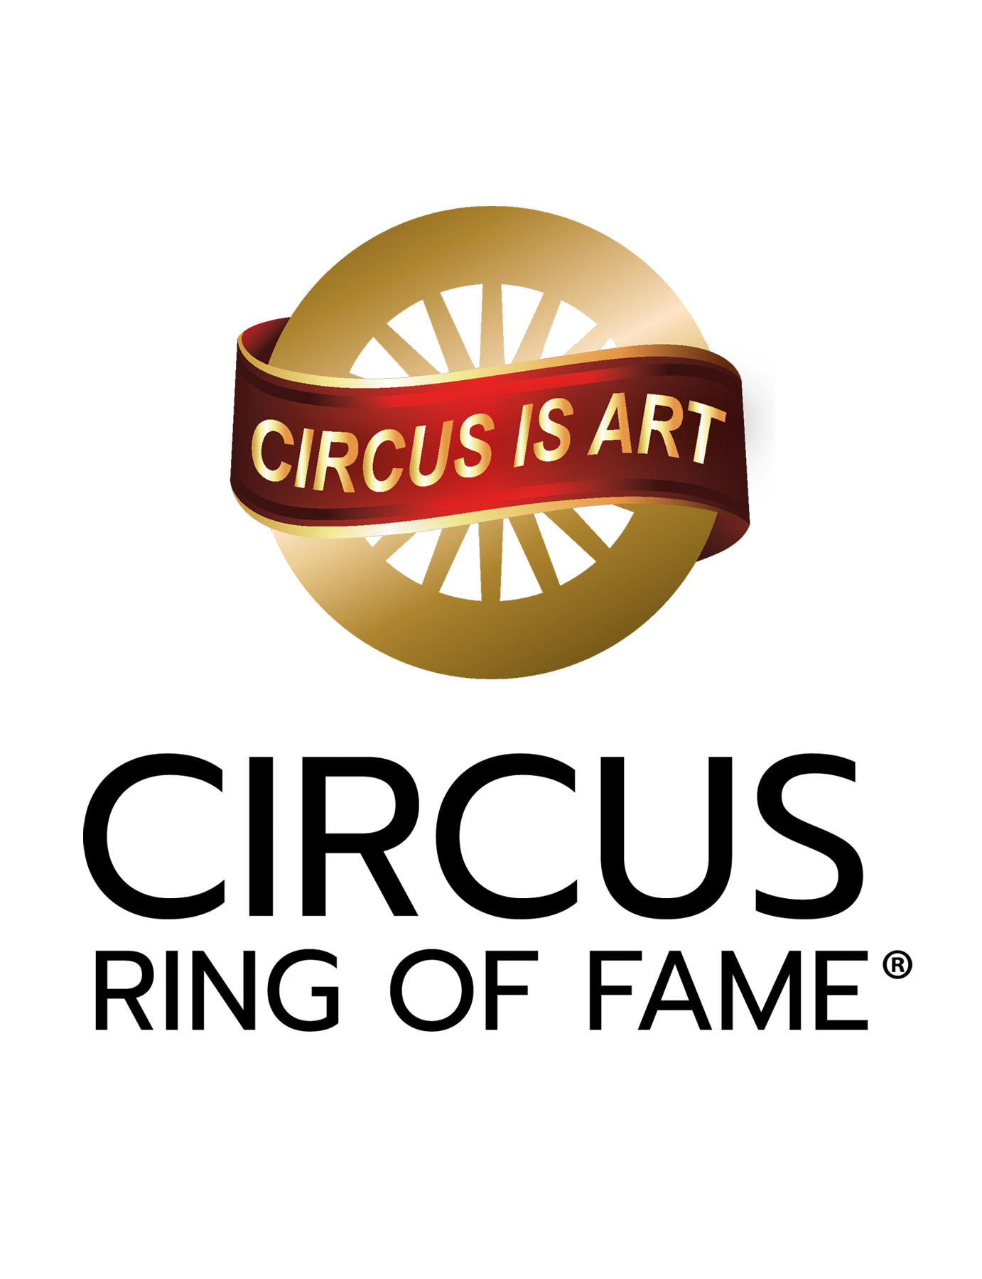

Awards Application

Please fill out this form in its entirety and return by e-mail to: circusringoffame@gmail.com
Submissions may also be sent via electronic document with attached supporting materials via a file sharing service such as Google Drive or Drop Box. No physical (USPS mail) submissions will be accepted. Incomplete or erroneous information may void submission.
Note: Support of the Foundation does not influence nomination, selection, or induction outcomes.
Supporting materials may include but are not limited to:
    - Photos
    - Videos
    - Copies of Awards
    - Letters of Recommendation
    - Online links to websites, video and other sources supporting the nominee’s candidacy

Deadline for submissions: APRIL 30

Select award you are submitting candidate/s for:
- Generation NeXt: ___ (please read qualification notes below before submitting)
- Coach of the Year: ___ (please read qualification notes before submitting)
- Circus Ring of Fame Lifetime Achievement:
- NOTE: Generation NeXt and Coach of the Year submissions should complete the form. Consideration of individual’s tenure will be taken into account.

Candidate information:

Birth Name:

First: __ __________
Last: ________________
Middle: ________

AKA (also known as) name: ________

Professional name:

Birth year:

Year deceased:

Birthplace:

Nationality:

Mailing and physical address:
Street
City
Country
Postal code

Phone:

Email:

Candidate Online Presence: Names of social media handles:
- Facebook:
- Instagram:
- Linkedin:
- TikTok:
- Pinterest:
- Twitter:
- X:
- YouTube:
- WhatsApp:
- Website:

How many generations has the individual or family been in the circus?

List Circus Arts Schools the candidate attended:
a.
b.
c.
d.

Did the candidate attend college or university? (For information purposes only. Lack of degree does not affect candidacy).

Undergraduate Degrees:
Professional Certifications:
Advanced Degrees:

Circus occupation(s). (for example: Clown, Aerialist, Trainer, and Juggler, management, etc.)
a.
b.
c.
d.
e.
f.
g.

Circus Arts debut:
Date:
Where:
Occupation or Act:

Provide names & dates of shows:
a.
b.
c.
d.
e.
f.
g.
h.
i.
j.

How many years has the candidate been active in the circus arts?
How many years was the candidate performing at the highest level?

Was the candidate featured in show advertising and publicity?
Provide examples in digital format .jpg .pdf via file sharing program

Provide examples of positive impact the candidate had on the Circus Arts industry
(for example, candidate developed the first or best prominent routine for X type of act).
a.
b.
c.
d.
e.
f.
g.

What kind of community service and mentoring did the candidate perform?
List any non-profit organization board or committee work. List any offices held:
a.
b.
c.
d.
e.
f.
g.

Is the candidate recognized widely within the global circus arts industry?
(1 to 10 scale with 10 being highest)
- North America ___
- Europe ___
- Asia ___
- South America ___
- Australia ___

Is the candidate in good standing within the circus industry?
Please explain why you believe this to be true and provide examples:

Appearances, with dates, in non-circus venues
(for example, fairs, tv, clubs, theaters, films):

a.
b.
c.
d.
e.
f.

For what was the candidate best known?
What is the candidate’s greatest achievement(s) The creation of, ownership of, and management of.

Prominent Honors, awards, special recognitions, with dates
(for example, AGT finalist, Monte Carlo Silver Clown etc.).
a.
b.
c.
d.
e.
f.

Submitted by (name of sponsor):
Name:
Address:
Phone:
Sponsor info:
E-Mail:
Phone:
Facebook:
Instagram:
Tik Tok:
Twitter:
WhatsApp:

LIFETIME ACHIEVEMENT CANDIDATE QUALIFICATIONS

Candidate:
May be either an individual or a group of two or more.
- May be anyone whose primary circus association has been for a substantial number of years.
- Must have played a major or featured role in the circus.
- Must have made a significant contribution to the circus.
- Must be in good standing in their community.
- Must be willing to travel in person to Sarasota or participate in a video to accept the award if conflicts arise (in person acceptance strongly advised).
- Sponsor of candidate must be willing to work with Circus Ring of Fame Board members to identify and secure funding for bronze wagon wheel and plaques (donors will receive an acknowledgement letter of said donation for tax purposes).Geo

GENERATION NEXT CANDIDATE QUALIFICATIONS

Candidate:
- Must be relatively early in their professional career.
- Must be willing to travel Sarasota and perform pro bono at the annual awards show and participate in the promotion of said show.
- Must be in good standing with the circus community.
- Must be a great artist deemed to have leadership potential to represent the next generation of the circus arts.
- Can be from a multi-generational family or a circus arts/acrobatic school.

WILLIE EDELSTON CIRCUS ARTS COACH OF THE YEAR QUALIFICATIONS

Candidate:
- Must be a current coach or retired coach.
- Must be in good standing with the circus community.
- Must be deemed by their peers to have had significant impact in the lives and careers of students.
- May or may not have a professional circus arts background but must have coached students who have gone on to circus careers.
- Must be willing to travel in person to Sarasota or participate in a video to accept the award if conflicts arise.
- Must be willing to participate in the promotion of said award and the Circus Ring of Fame Awards Show
Submit with Supporting Documents via email to:
circusringoffame@gmail.com
Send large files to us via: Apple Mail Drop or Google Drive.

