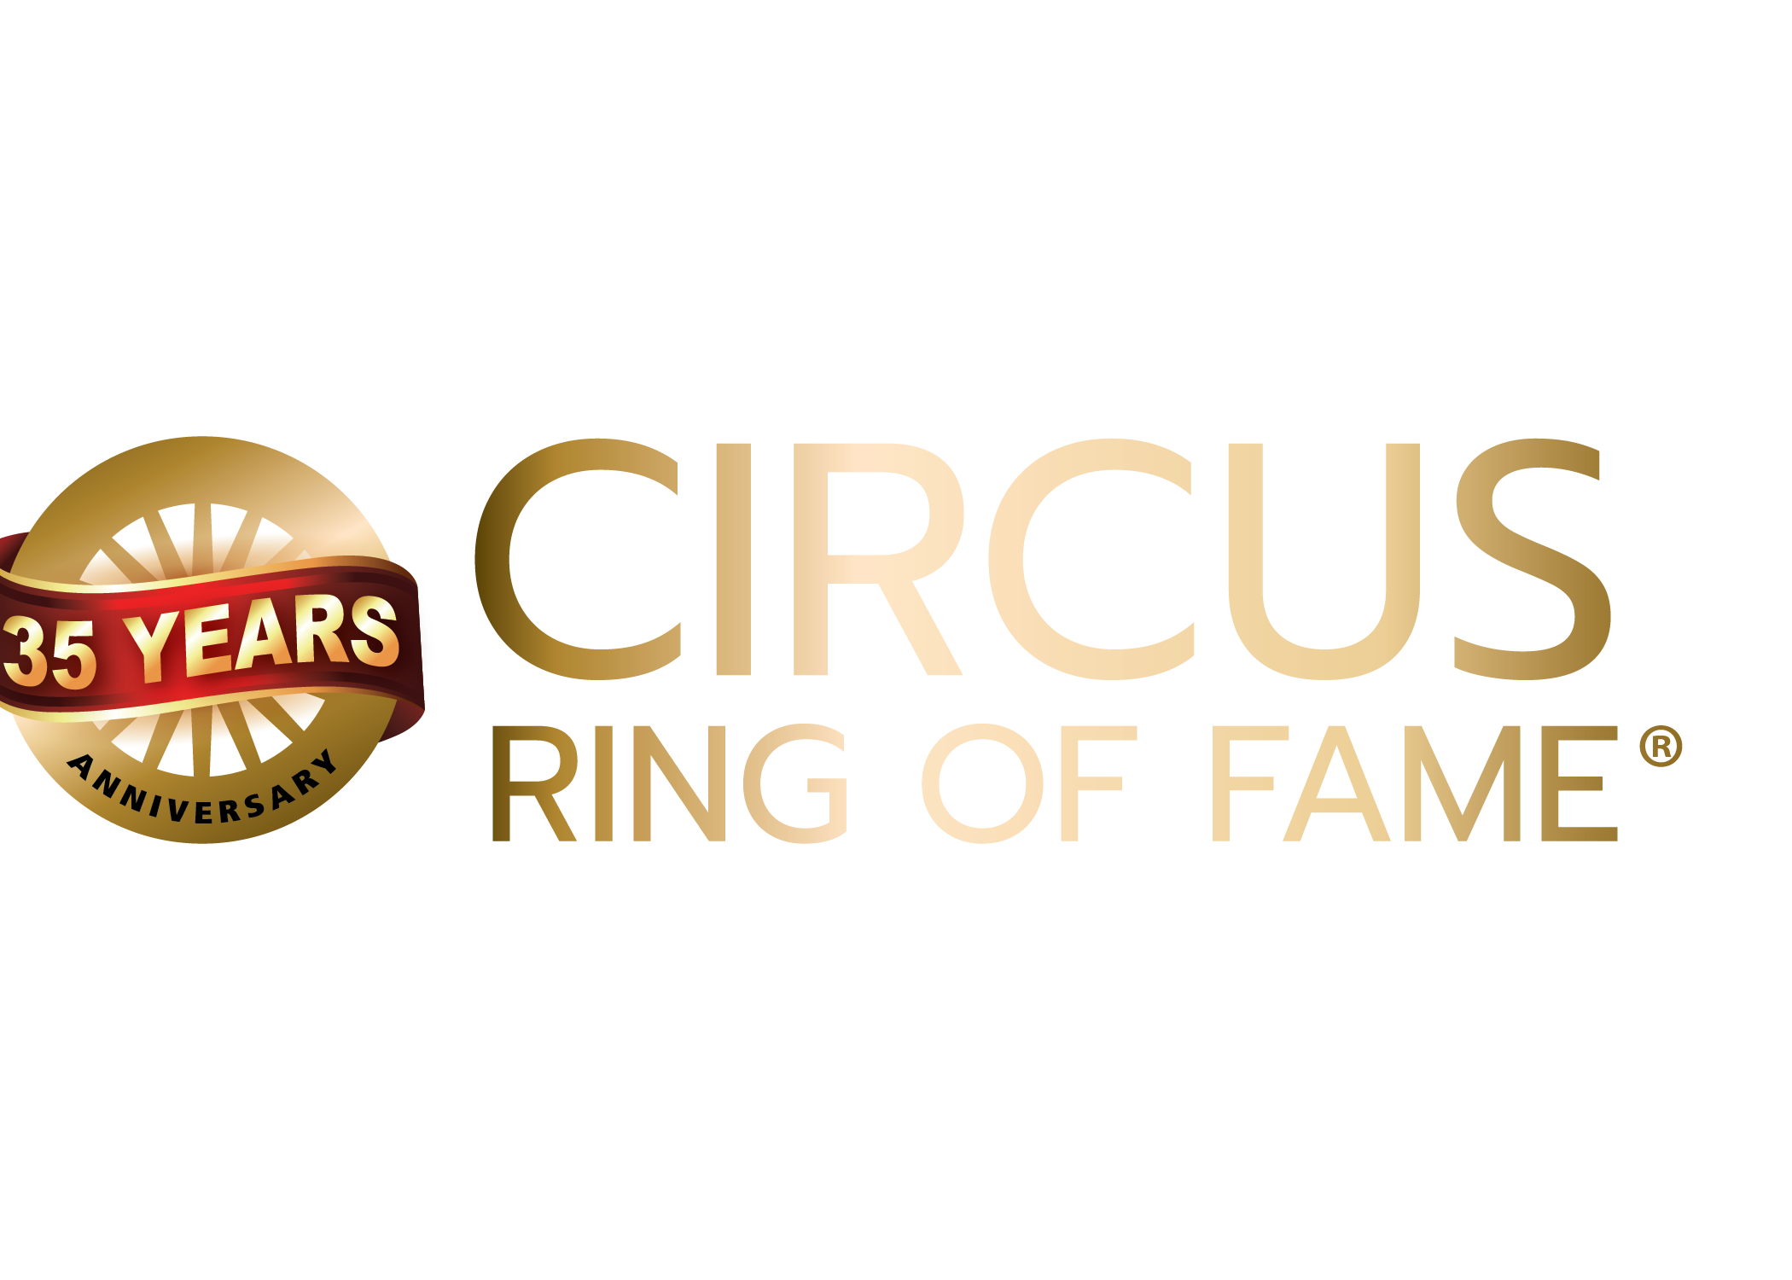
Awards Application

Please fill out this form in its entirety and return by e-mail to: circusringoffame@gmail.com
Submissions may also be sent via electronic document with attached supporting materials via a file sharing service such as Google Drive or Drop Box. No physical (USPS mail) submissions will be accepted. Incomplete or erroneous information may void submission.
Supporting materials may include but are not be limited to:
    - Photos
    - Videos
    - Copies of Awards
    - Letters of Recommendation
    - Online links to websites, video and other sources supporting the nominee’s candidacy

Deadline for submissions: APRIL 30

Select award you are submitting candidate/s for:
- Generation NeXt: ___ (please read qualification notes below before submitting)
- Coach of the Year (NEW): ___ (please read qualification notes before submitting)
- Circus Ring of Fame Lifetime Achievement: ___
- NOTE: Generation NeXt and Coach of the Year submissions should complete the form. Consideration of individual’s tenure will be taken into account.

Candidate information:

Birth Name:

First: ______________ Last: ________________ Middle: ________

Birth year:

Year deceased:

Birthplace:

Nationality:

Professional name:

Mailing and physical address:
Street
City
Postal code

Phone:

Email:

Candidate Online Presence: Names of social media handles:
- Facebook:
- Instagram:
- Linkedin:
- TikTok:
- Pinterest:
- Twitter:
- Other:
- YouTube:
- WhatsApp:
- Website:

How many generations has the individual or family been in the circus?

List Circus Arts Schools the candidate attended:
a.
b.
c.
d.

Did the candidate attend college or university? (Note: for information purposes only)

Undergraduate Degrees:
Certifications:
Advanced Degrees:

Circus occupation(s). (for example: Clown, Aerialist, Trainer, and Juggler etc.)
a.
b.
c.
d.
e.
f.
g.

Circus Arts debut:
Date:
Where:
Doing:

Provide names & dates of shows:
a.
b.
c.
d.
e.
f.
g.
h.
i.
j.

How many years has the candidate been active in the circus arts?
How many years was the candidate performing at the highest level?

Was the candidate featured in show advertising and publicity?
Provide examples in digital format .jpg .pdf via file sharing program

Provide examples of positive impact the candidate had on the Circus Arts industry
(for example, candidate developed the first or best prominent routine for X type of act).
a.
b.
c.
d.
e.
f.
g.

What kind of community service and mentoring did the candidate perform?
List any non-profit organization board or committee work. List any offices held:
a.
b.
c.
d.
e.
f.
g.

Is the candidate recognized widely within the global circus arts industry?
(1 to 10 scale with 10 being highest)
- North America ___
- Europe ___
- Asia ___
- South America ___
- Australia ___

Is the candidate in good standing within the circus industry?
Please explain why you believe this to be true and provide examples:

Appearances, with dates, in non-circus venues
(for example, fairs, tv, clubs, theaters, films):

a.
b.
c.
d.
e.
f.

For what was the candidate best known?

What is the candidate’s greatest achievement(s) ?

Prominent Honors, awards, special recognitions, with dates
(for example, AGT finalist, Monte Carlo Silver Clown etc.).
a.
b.
c.
d.
e.
f.

Submitted by:
Name:
Address:

Phone:
Sponsor info:
E-Mail:
Phone:
Facebook:
Instagram:
Tik Tok:
Twitter:
WhatsApp:
Submit with Supporting Documents via email to:
circusringoffame@gmail.com
Send large files to us via: Drop Box or Google Drive.

CIRCUS RING OF FAME®

RULES AND PROCEDURES FOR SELECTION OF CIRCUS RING OF FAME® MEMBERS

The annual ceremony takes place the first week of February. For consideration, all supporting information must be received by April 30th of the preceding year.

All submissions and material must be submitted online via email or FTP/file sharing service such as Google Drive or DropBox.

For the selection of the Circus Ring of Fame® inductees for next year the nominating committee will produce a slate of candidates according to the Rules and Procedures for Selection of the Circus Ring of Fame®.

The new members of the Circus Ring of Fame® who will be inducted in February will be those nominees who receive the greatest number of votes. The electors will be comprised of both the nominating committee and Circus Advisory Council online voting feedback forum.
Prior to starting the selection process, the Circus Ring of Fame® Foundation Executive Committee and Nominating Committee will establish (a) the maximum number of nominees whose names can appear on the ballot, (b) the maximum number of winners.
Person or persons nominating a candidate must be prepared to assist in seeking sponsorship funding for the plaque and wheel plus installation at St. Armands Circle.
A candidate is either an individual or group qualified to be a Circus Ring of Fame® inductee and whose name has been submitted to the Nominating Committee for consideration to become a nominee. Nominees are selected by vote of the committee, based on the candidate submissions.
The Circus Ring of Fame® Executive and Nominating Committees will established that a maximum number of nominees for any given year. The Executive Committee will determine the sponsor contribution.
Candidates may originate from any source. Each candidate must meet the criteria for membership as set forth under candidate qualification. Candidate submission forms may be obtained from the link on the Circus Ring of Fame® website. All candidate applications must be complete.
Submissions for upcoming years will be accepted until the date designated (APRIL 30, 2023) and published by the Circus Ring of Fame® Foundation.
The selection of final inductees will be by vote of Nominating and Executive Committee members (with input from the Circus Advisory Council) at a meeting scheduled by the Executive Committee. Circus Advisory Council feedback will be by online voting platform only.
By majority vote of its members the Nominating Committee (with the approval of the Executive Committee) may void any of the results of votes. Background checks of candidates are at the discretion of the executive committee.
By majority vote of its members the Nominating Committee (with the approval of the Executive Committee) may elect new Ring of Fame® inductees independently of all other procedures for electing members. Accordingly, the Nominating Committee is also, at its discretion, and with the approval of the Executive Committee, allowed to select a performing animal as a select member based on proper submission of said animal for consideration.

Qualifications for award categories:

LIFETIME ACHIEVEMENT CANDIDATE QUALIFICATIONS

Candidate:

May be either an individual or a group of two or more.
- May be either living or deceased.
- May be anyone whose primary circus association has been for a substantial number of years.
- Must have played a major or featured role in the circus.
- Must have made a significant contribution to the circus.
- Must be in good standing in their community.
- Must be willing to travel in person to Sarasota or participate in a video to accept the award if conflicts arise (in person acceptance strongly advised).
- Sponsor of candidate must be willing to work with Circus Ring of Fame Board members to identify and secure funding for bronze wagon wheel and plaques (donors will receive an acknowledgement letter of said donation for tax purposes).

GENERATION NEXT CANDIDATE QUALIFICATIONS

Candidate:
- Must be relatively early in their professional career.
- Must be willing to travel Sarasota and perform pro bono at the annual awards show and participate in the promotion of said show.
- Must be in good standing with the circus community.
- Must be a great artist deemed to have leadership potential to represent the next generation of the circus arts.

WILLIE EDELSTON CIRCUS ARTS COACH OF THE YEAR QUALIFICATIONS

Candidate:

- Must be a current coach or retired coach.
- Must be in good standing with the circus community.
- Must be deemed by their peers to have had significant impact in the lives and careers of students.
- May or may not have a professional circus arts background but must have coached students who have gone on to circus careers.
- Must be willing to travel in person to Sarasota or participate in a video to accept the award if conflicts arise.
- Must be willing to participate in the promotion of said award and the Circus Ring of Fame Awards Show.

THE CIRCUS RING OF FAME® FOUNDATION, INC. IS A 501(c)3 Corporation and contributions may be tax deductible. You are encouraged to consult your tax preparer for determination.

A COPY OF OUR OFFICIAL REGISTRATION AND FINANCIAL INFORMATION MAY BE OBTAINED FROM THE DIVISION OF CONSUMER SERVICES BY CALLING TOLL-FREE 1-800-435-7352 WITH IN THE STATE OR VIA THE INTERNET AT WWW.800HELPFLA.COM. OUR REGISTRATION NUMBER IS CH5271. REGISTRATION DOES NOT IMPLY ENDORSEMENT, APPROVAL OR RECOMMENDATION BY THE STATE.

